**Lifelong Learning Institute of Elkhart County**

**“Golden Years Academy: Explore, Learn, Create!”**

**Goshen College Campus**

**June 2-June 5, 2025**

**June 2 - 8:30-9:00** Welcome and Orientation Welcome Center and Union 111

**June2 9:30-10:30 am Union – Gamelan Room**

**Nyai Oyer Gamelan Experience**

Marcia Yost

In this experience, you will learn about the role of gamelan in Indonesian culture. You will also learn about our gamelan’s journey to Goshen College as well as enjoy the unique opportunity of making gamelan music together. No experience required — only an adventurous spirit!

Marcia Yost is Goshen College Director of the Arts: Engagement and Outreach

**June 2 10:45-11:45am Union 111**

**The Potawatomi of Michiana, past and present**

Rich Meyer  
Every descendant of European settlers should be able to answer three questions about our Indigenous neighbors: whose land was this before colonization, how did they lose it, and where are their descendants today? Participants in this session will learn this and more. A brief history of the removal period, diaspora and fragmentation, then survival and resurgence, up to the present.

Rich Meyer has been the navigator for a number of groups following the route of the 1838 Trail of Death, the forced removal of Potawatomi from Indiana. Through these he has learned to know Potawatomi historians, artists, cooks and tribal leaders, and assists Mennonite institutions in building connections with Potawatomi resource people.

**June 2 1:30-2:30 pm Rec Fitness Center**

**Pickleball (and Table Games)**

David Jansen

Having played tennis at Bethel (KS), Pickleball was a welcome discovery about 12 years ago. I am a retired HR director from GC, having lived in Elkhart and Goshen since 1969. Member of Fellowship of Hope Mennonite Church in Elkhart.

This picture shows we enjoy social time together in our Pickleball group.

**June 2 2:45-3:45 Library 3rd floor**

**Genealogy Journey: Discovering Your Ancestral Story**

Eric Bradley

Want to learn more about your family roots, but don’t know where to start? This session will introduce you to the genealogy (family history) collection of Goshen College’s Mennonite Historical Library and look at the print and online genealogical resources available at the MHL and offer best practices for beginning (or furthering) family history research. You may leave learning something new about yourself!

Eric Bradley is the Head Librarian of the Mennonite Historical Library at Goshen College, where he oversees operations for a comprehensive collection of resources on Amish, Hutterites, Mennonites, and related groups.

**June 2 4-5 pm Good Library**

**Normalizing Academic Support**

Jan Kauffman

How have GC's demographics changed in the past 10 years?  What factors impact students' persistence toward graduation?  What is the Developing HSI grant?  Who works in the Academic Success Center?  Come meet some of the staff in the ASC and hear about how we are normalizing academic support and expanding our services to reach more students.

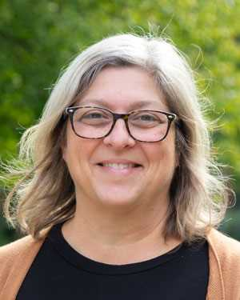Jan Kauffman is the Associate Dean of Student Success. “Normalizing Academic Support” Her blend of experience with student life and academic affairs has allowed her to approach her work with a lens for student success and a broad understanding of higher education.

**June 3 9-10 am Music Center Classroom 100**

**Promoting Campus Sustainability**

Dan Barwick

In this class, students will explore the role of the Sustainability Coordinator in fostering conservation and sustainability efforts across campus. They'll learn how to enhance environmental stewardship by supporting the maintenance of campus buildings, grounds, and systems. Additionally, students will understand the importance of collecting and reporting data related to Goshen College's sustainability initiatives and related designations, promoting a holistic approach to campus sustainability.

Dan Barwick, a Goshen College graduate and now Sustainability Coordinator at the college. When he lived in Denver, CO he played a pivotal role in deploying 200 electric vehicles for Lyft's Express Drive program in Colorado, marking the largest single deployment of EVs in the state's history. After nearly a decade in Denver, he returned to Goshen where he continues to champion environmental initiatives.

**June 3 10:15-10:30 am Travel 10:30 – 11:30 am Luke Gascho’s place**

**Edible Forest Tour**

Luck Gascho

Luke will lead a tour of his 2.5-acre fruit, nut and berry orchard. He will explain how this orchard is an example of regenerative agriculture. Participants will learn about the strengths of a polyculture design, how soil health is nurtured, and the holistic way pests are managed. The group will consider the opportunities to promote resilient food systems

Luke Gascho served as executive director of Merry Lea Environmental Learning Center of Goshen College, Wolf Lake, IN for twenty-two years until his retirement in 2019. He was the chair of the sustainability and environmental education department at Goshen College.

**June 3 1:30-2:30 pm Visual Arts Building**

**A Quick Introduction to Clay**

Merrill Krabill

We will talk a little bit about clay and what making ceramic pieces is like. Mostly you will have a chance to play around with clay--it's a wonderful material. You will be able to make a small piece that will be fired and available a couple of weeks after our session is finished. No experience is required.

Merrill Krabill had been on the faculty at Goshen College from 2001-24. In addition to the importance of educating the next generation of students, the opportunity to see young artists engage the world of visual expression with fresh eyes opened new possibilities for him personally as well.

**June 3 2:45-3:45 pm Westlawn**

**New Life for an Historic Building: The Renovation of Westlawn Hall**

Brian Mast

Westlawn Hall was built in 1950 to house the new dining hall and to serve as a women's dormitory. With the upper to floors lying dormant since the late 1990's, come hear about how this space has found a new life as a the state-of-the-art Center for Nursing and Public Health, newly renovated kitchen/dining hall, and renovated lobby and commons space. Be sure to wear your walking shoes as we explore this new space!

Brian Mast has worked at Goshen College for 21 years and is deeply committed to the mission of Goshen College and creating spaces that allow students, faculty and staff to thrive in their work and education.

**4:00-5:00 pm West Lawn – Mark Community Room**

**Maple Scholar Student Projects at Goshen College 2025**

Andy Ammons

We will learn about Maple Scholars, an intensive 8-week research experience for Goshen College students who work with a faculty or campus mentor over the summer.  In a community of scholars, mentors and students meet together weekly to discuss and present progress on projects ranging from the arts to the sciences and humanities.  Goshen College Maple Scholars will briefly present the projects they are a part of for this summer.

Andrew Ammons (Andy) is a Professor of Biological Sciences at Goshen College. Dr. Ammons studies honey bee (*Apis mellifera*) behavioral genetics, and he and his students have analyzed such human-relevant behaviors as aggression, alcohol sensitivity, aging, and circadian rhythm in bees.

**June 4 9:00-10:30 CMC Koinonia Room**

**Wednesday options**:

**Pumpkinvine Trail Story & Bike to Shipshewana**

Norm Kauffmann, a founding member of the Pumpkinvine Committee, will coordinate a group of presenters to tell the Pumpkinvine Trail story and then go on a bike ride on the Pumpkinvine. You can use your own bike or rent a bike at $30 for the day.

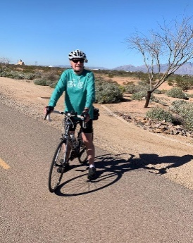

**June 4 11:00am – 3:30pm van trip**

**Lunch at Mooy’s in Middlebury and Shipshewana Flee Market** visit- We will take a van to meet the bikers at Mooy’s for lunch (lunch not included in the cost of the registration). After lunch we’ll go to Shipshewana Flee Market for a couple hours.

**June 5 9:00-10:00 am – Umble Center**

**Come Play with the Stars!**

Amy Budd

Have you ever wondered how Goshen College brings fresh, exciting theater to life on the Umble Center Stage? Join theater students and Associate Professor Amy to learn about the steps involved in crafting productions for audiences. You’ll even have a chance to try your hand at working with a short, contemporary script.

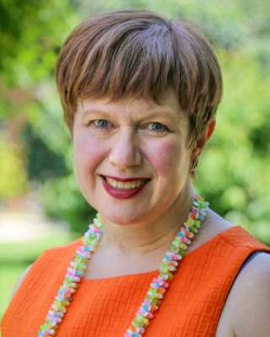

Amy Budd has worked as a theater artist and educator for thirty years, collaborating with professionals and learners of all ages. Amy teaches performance and history courses here at GC.

**June 5 10:15-11:15 Newcomer Communications**

**Inside The Globe**

Jason Samuel

Attendees will tour the station and hear a brief history of The Globe and the Center for Communication Studies. Camp-goers will learn about communication department success, student involvement and the relationship between the radio station and the community

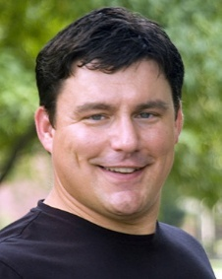

Jason Samuel is an associate professor of communication and director of Globe media. He is a 1992 graduate of Goshen College. He has been employed at his alma mater since 2003. Under his leadership, the radio station has received many state and national awards, including best in the country five times and best in the state ten times.